Museum of Enfield

Object Handling Resource Pack Booking Document

April 2026 to March 2027

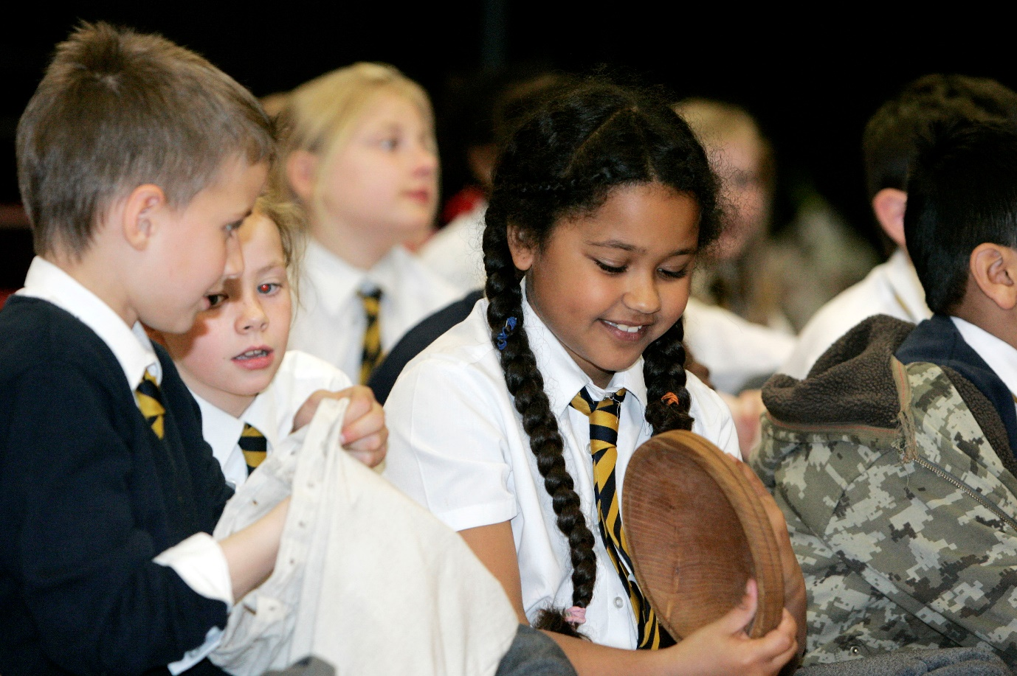

Loans Booking Request Form

Please email the museum for pack content lists prior to sending in your booking request.

Main contact details: |  | Date:
School name and full address:
Invoicing contact (if outside London Borough of Enfield)
Packs requested:  Please highlight your selection  All packs are loaned for a 4-week period | Large Pack £25 Small Pack £20  Anglo Saxon The Blitz  Enfield during WWI Currency  Toys Looking Good  Household and Homes Metals  Ghana and the Transatlantic Slave Trade Numbers  Ancient Rome Sewing and Mending  Victorians Tiny Toys  World War Two Old Toys  Britain since 1948: the Windrush Years Wartime Food  Writing  FREE  Prehistory  Can’t see what you are looking for? Please provide additional details below of the topic you are after:
Preferred date/term:
Year group and expected number of children using resource | Year Group:  Expected number of Children:

Return your completed booking form to museum@enfield.gov.uk

Once received, we will send a booking confirmation within 5 working days confirming your request, and available loan collection and return dates. Boxes must be collected and returned to the following address:

Bowes Road Library Building
269 Bowes Road
London
N11 1BD

Packs and themes are subject to availability.

It might be possible to create a bespoke pack, depending on the theme and content within our wider handling collection. Please email the museum team to enquire.

Bespoke packs are charged at £40 for a 4-week loan period.

If you no longer require the pack, contact the museum as soon as possible as it may have been requested by another school or community group.

If you are unable to return the pack on the booked return date, contact the museum as soon as possible to avoid a late fee charge. Failure to return the pack on the scheduled return date will result in a late fee of £10 per week.

With the exception of the free Prehistory Pack, a £10 deposit is required once the booking has been confirmed. The deposit will be taken off the total cost of the pack once it has been returned on the specified date and with no damaged or missing objects.

Terms and Conditions

- The main contact is responsible for ensuring that all objects are cared for, collected, and returned.

- At the end of the loan period, all objects must be placed back in their correct packs using the inventory sent through with your booking confirmation. Inform the museum team as soon as possible of any breakages or missing items before returning the pack.

- A late fee of £10.00 per week will be incurred if the pack is not returned by the specified date. Late packs may impact other schools and groups using the resource. If you are unable to return the pack on the specified return date, you must notify the museum team as soon as possible.

- Objects are not to be buried or submerged in water or liquid

- Eating and drinking is not permitted around the objects. Food and drink left on the objects or packs can damage the object and attract pests in the museum store once returned.

- Do not affix labels, Sellotape or tac to the objects

- Do not attempt to repair or modify the objects in any way

- The cost of any missing or damaged object will be deducted from your deposit and your school may be charged the difference if the deposit does not cover the cost of replacement or repair.

- Always pick up an object with both hands and support its weight underneath where necessary

- Potential risks and mitigations are identified in the relevant risk assessment (EMS_RA_22 Object Handling Resource Packs)

By making a booking and returning this form, your organisation is agreeing to the terms and conditions laid out above.

Contact Name:
Contact signature:
Date:

If you have any queries or require further information, please do not hesitate to contact museum@enfield.gov.uk

This collection is made for handling by children and adults, and we want everyone to feel confident and to enjoy working with the objects.

